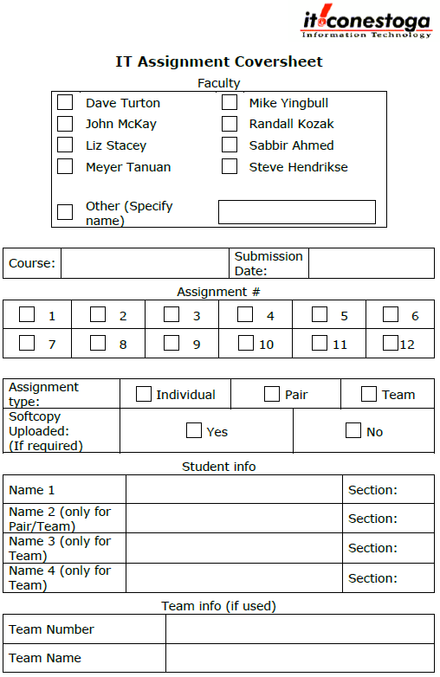

**√V**

**Heuijin Ko Sec3**

**√V**

**√V**

**√V**

Jan 25, 2020

Programming Mobile

Web Applications I

**Marking Sheet**

|  |  |  |  |
| --- | --- | --- | --- |
|  | **Description** | **Marks Allocated** | **Marks Achieved** |
| 1 | Home Page designed as specified | 15 |  |
| 2 | Add a Feedback page is designed as specified | 20 |  |
| 3 | List of Reviews page is designed as specified | 15 |  |
| 4 | Modify Feedback page is designed as specified | 15 |  |
| 5 | Settings page is designed as specified | 10 |  |
| 6 | Every page has 3 main sections. | 10 |  |
| 7 | Header and footer are fixed. | 5 |  |
| 8 | 5 Screenshots | 10 |  |
| **Deduction** | | | |
|  | Assignment Standard | 5 x ________ |  |
|  | id attribute is missing for any input control | 3 x ________ |  |
|  | name attribute is missing for any input control | 3 x ________ |  |
|  | Id, name not prefixed with initial | 2 x ________ |  |
|  | Programming Standard | 1 x ________ |  |
|  | Bug | 3-10 based on severity |  |
|  | Late | ­­_________days |  |
|  | No Demo | 40 |  |
|  | No hardcopy | 100 |  |
| **Total** | |  |  |